Purpose and Scope
This process describes the procedure for identifying product by suitable means from receipt through delivery and for recording unique identification including Pack number, Lot number and/or Heat number.

Process
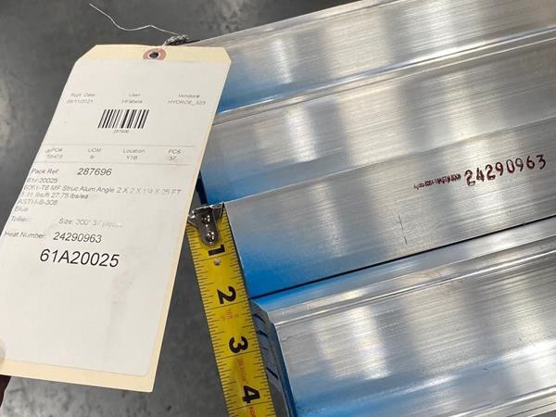
- Receiving Inspector
Identify material with Stock tags. A minimum of one Stock tag is required on each bundle or skid.

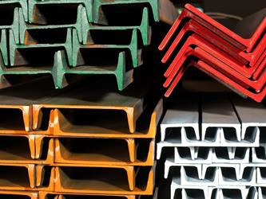
- Receiving Inspector
Paint at least one end of material as required per Appendix 1 Tables 1 through 8.
See Procedure Statement B.

Process
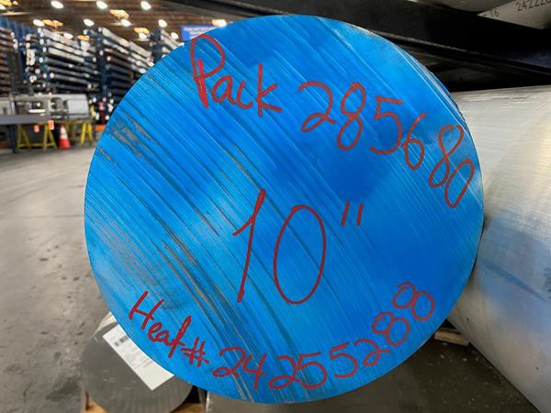
- Receiving Inspector
If tagging is not appropriate (e.g. large rounds) mark Pack# and Heat/Lot# on each piece.

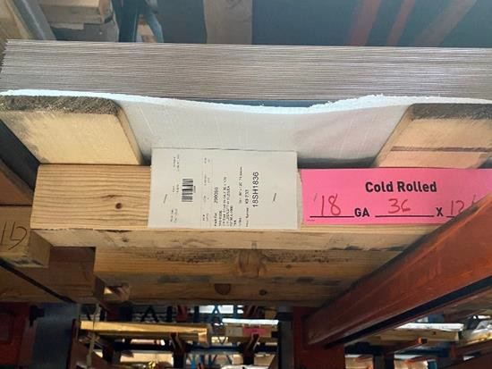
- Receiving Inspector
For skids of sheet or plate, attach colored paper with alloy type identified as required per Appendix 1 Table 1.

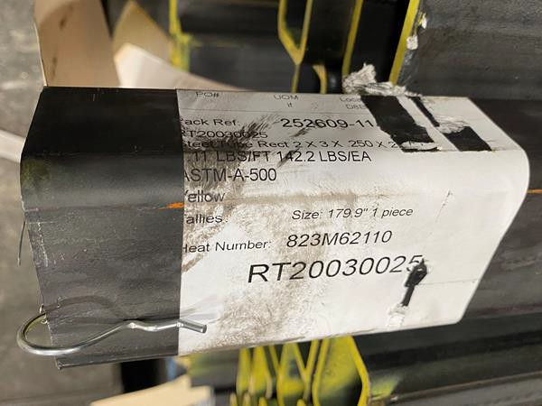
- Material Handler
Maintain/transfer identification, including Pack# and Heat# or Lot# on unmarked material that is being returned to stock for future use, as necessary and per steps
1-4 above.

Procedure Statements
  - Store Items are not tagged with Stock tags and no traceability is maintained.
  - Materials are painted in accordance with Appendix 1 Tables 1 through 8 to indicate material type and thickness. If material is surface or cosmetically critical, then paint can be applied to Stock tag or outside packaging and not directly to product.
  - Traceability to Heat and/or Lot number from mill certifications is maintained as required per Appendix 2.
  - Any products not identified in the tables are designated as non-color coded products.
  - The functions may be performed by anyone as identified by Management and trained in the process.
  - Each Branch is responsible for maintaining a clear and consistent method for identifying/marking product with special requirements (e.g. DFAR’s) as needed and segregating Pack# and Heat/Lot# in the same pan.
  - If material does not have stenciling or is deemed as a fairly expensive product that potentially runs the risk of losing traceability because of only having one tag, then the Branch may need to tag bundles on both ends.
  - Colors used in this document are examples only. Paint and paper colors may not exactly match.
  - Color coding in the Store/Rems areas may be used but is not controlled nor a requirement of the Product Identification process.
  - Material painted Purple indicates material that has been reclassified as non-traceable.
  - Material that we do not apply paint to is:
    - Aluminum sheet
    - 6063 tubing
    - Stainless sheet
    - Stainless Polished, Satin tubes
    - Copper sheet
    - Brass sheet
    - Cold Rolled sheet
    - Galvanized sheet
    - Corrugated
    - Customer Dedicated
    - Brokered

Risks and Mitigations

Risks | Mitigations
Lack of understanding requirement. | Verify competency and knowledge of associates, training records.
Loss of identification therefore loss of traceability which will result in financial loss as material is scrapped or regraded to Rems. | Product Handling, Storage and Preservation (QSP 15.1), In-Process Inspection (QSP 10.2).
Color Blindness. | Awareness, QSI 10.1.1, Receiving Inspection (QSP 10.1), In-Process Inspection (QSP 10.2).
Inadequate identification materials available. | Overstock, local supply sources, storage locations, supply requests.
Potential devaluation of material from paint or glue. | Train and identify what qualifies as cosmetically critical material (see Procedure Statement), knowledge and competency of Product Handling, Storage and Preservation (QSP 15.1).

Reference and Applicable Documents
QSM-9000 Quality Processes Manual Appendix 1 Material Color Codes
Appendix 2 Material Traceability Requirements

Personnel to be Trained
Warehouse Personnel Purchasing Personnel Sales Personnel
Branch Admin/Quality Manager

Revisions Table

Date | Description of Change | Approved by
9/8/21 | Updated document format, added visuals and Appendices. | Melissa DaSilva Penny Brown

Table 1 – Sheet and Plate Skids

Material | Paper/Paint Color |  | Recorded Information
Copper | Pink |  | Thickness (or Wgt/Sqft) x Width x Length
Brass | Yellow |  | Thickness x Width x Length
2024 Aluminum | Brown |  | Thickness x Width x Length
3003 Aluminum | Pink |  | Thickness x Width x Length
4017 Aluminum | Red |  | Thickness x Width x Length
5052 Aluminum | Green |  | Thickness x Width x Length
5086 Aluminum | Orange |  | Thickness x Width x Length
6061-T4 Aluminum | White |  | Thickness x Width x Length
6061-T6 Aluminum (Import) | Gold |  | Thickness x Width x Length
6061-T6 Aluminum (Domestic) | Blue |  | Thickness x Width x Length
6061-T6 Aluminum (DFARs) | White | Blue | Thickness x Width x Length
6061-O Aluminum | Yellow | Green | Thickness x Width x Length
7075 Aluminum | Pink | Blue | Thickness x Width x Length
Aluminum Tooling | White |  | Thickness x Width x Length
Cold Rolled | Pink |  | Gauge (or Thickness) x Width x Length
Galvanized G90 | White |  | Gauge (or Thickness) x Width x Length
Galvanized G60 | Brown |  | Gauge (or Thickness) x Width x Length
Galvanized G40 | Green | Brown | Gauge (or Thickness) x Width x Length
Galvannealed (Jet Coat) | Blue |  | Gauge (or Thickness) x Width x Length
Electro-Galv (Paintlok) | Yellow |  | Gauge (or Thickness) x Width x Length
Bonderized | Orange |  | Gauge (or Thickness) x Width x Length
Hot Rolled Pickled & Oiled | Yellow + Table 3 |  | Gauge (or Thickness) x Width x Length
Hot Rolled | No Color + Table 3 |  | Gauge (or Thickness) x Width x Length
Hot Rolled GR50 | Pink + Table 3 |  | Gauge (or Thickness x Width x Length
Hot Rolled A606 (HSLA/Corten) | Blue | Red | Gauge (or Thickness) x Width x Length
AR400 | Blue |  | Gauge (or Thickness) x Width x Length
AR500 | Orange |  | Gauge (or Thickness) x Width x Length
4130 | Blue | Gold | Thickness x Width x Length
Corrugated Galvanized | White |  | Gauge (or Thickness) x Width x Length
Corrugated Galvalume | Orange |  | Gauge (or Thickness) x Width x Length
Corrugated (no coating) | Pink |  | Gauge (or Thickness) x Width x Length
Stainless 304 2B or MF | Red |  | Gauge (or Thickness) x Width x Length
Stainless 304 #4 | Blue |  | Gauge (or Thickness) x Width x Length
Stainless 304 #8 | Yellow |  | Gauge (or Thickness) x Width x Length
Stainless 316 2B or MF | Green |  | Gauge (or Thickness) x Width x Length
Stainless 316 #4 | Green | Blue | Gauge (or Thickness) x Width x Length
Stainless 430 2B or MF | Orange |  | Gauge (or Thickness) x Width x Length
Stainless 430 #4 | Orange | Blue | Gauge (or Thickness) x Width x Length
Stainless 430 BA | Orange | Pink | Gauge (or Thickness) x Width x Length
Paper tags or paint can be used to identify material.
If colored paper is not available then paper tag, stock tag, skid, or material can be painted with applicable color designation.
If no color designation is listed, White tags can be used.

Table 2 – Long Products (Bars, Shapes, Tube & Pipe)

Material/Alloy | Paint Color
Stainless Type 303** | Pink
Stainless Type 304** | Yellow
Stainless Type 316** | Blue
Stainless Type 17-4 | Green
Cold Rolled 1018 | Red
Cold Rolled 12L14 | Gold
Cold Rolled 1045 | Black
4140/4142 Alloy | Green
4130 Alloy | Pink
DOM | Gold
Hot Rolled | No Color + See Table 3
Rebar | No Color + See Table 3
Hot Rolled Pickled & Oiled | Orange
Hot Rolled Standard Beam | Blue
Hot Rolled W-Beam | Yellow
Uncoated Pipe | Silver
Coated (Black) Pipe | No Color
Aluminum 6061 | Blue
Aluminum 6101 | Green
Aluminum 7075 | Red
Aluminum 5086 | Orange
Brass* | Red
Copper* | Orange
*Paint should be applied to Stock tag or outside packaging.
**Stainless True Bar add Black to designated colors to identify as True Bar.

Table 3 – Hot Rolled Steel Sheet, Plate, Tube, Angle, Tee, RD Bar, SQ Bar, Flat Bar, and Rebar

Thickness | Paint Color | Thickness | Paint Color
18 Gauge | Pink | 1/2” | White
16 Gauge | White | 5/8” | Green
14 Gauge | Green | 3/4” | Black
13 Gauge | Red | 7/8” | Silver
12 Gauge | Gold | 1” | Pink
11 Gauge | Orange | 1-1/8” | Orange
10 Gauge | Pink | 1-1/4” | Yellow
7 Gauge | Black | 1-1/2” | White
1/8” | Orange | 1-3/4” | Black
3/16” | Blue | 2” | Pink
1/4” | Yellow | 2-1/2” | White
5/16” | Green | 2-3/4” | Black
3/8” | Red | 3” | Pink
For Hot Rolled Picked & Oiled Sheet/Plate items add Yellow to designated colors to identify as P/O material. For Laser Quality Sheet/Plate items add Green to designated colors to identify as LQ material.

Table 4 – Flat Expanded Metal

Size | Paint Color
#9 | Orange
#13 | Red
#16 | White
#24 | Yellow
For Raised items add Blue to designated colors to identify as Raised vs. Flat.
For Galv Expanded Sheet add Black to designated colors.

Table 5 – Steel Channel

Size | Paint Color | Size | Paint Color
3” x 4.1 lbs/ft | Blue | 6” x 8.2 lbs/ft | Red
3” x 3.5 lbs/ft | Red | 6” x 10.5 lbs/ft | Pink
3” x 5.0 lbs/ft | White | 6” x 12 lbs/ft | Brown
4” x 4.5 lbs/ft | Brown | 7” x 9.8 lbs/ft | Yellow
4” x 5.4 lbs/ft | Gold | 8” x 11.5 lbs/ft | Orange
4” x 6.25 lbs/ft | Yellow | 8” x 13.75 lbs/ft | Red
4” x 7.25 lbs/ft | Green | 9” x 13.4 lbs/ft | Green
4” x 13.8 lbs/ft | White | 10” x 15.3 lbs/ft | Blue
5” x 6.7 lbs/ft | Silver | 10” x 20.0 lbs/ft | White
5” x 9.0 lbs/ft | Black | 12” x 20.7 lbs/ft | Black

Table 6 – Steel Beams

I-Beam | Paint Color | WF-Beam | Paint Color
3 x 5.7# | Blue | 4 x 13# | Blue
3 x 7.5# | Green | 5 x 16# | Green
4 x 7.7# | Red | 5 x 19# | Red
4 x 9.5# | Orange | 6 x 9# | Orange
5 x 10# | White | 6 x 12# | White
5 x 14.75# | Yellow | 6 x 15# | Yellow
6 x 12.5# | Brown | 6 x 16# | Brown
6 x 17.25# | Blue | 6 x 20# | Blue

Table 7 – Steel Pipe

Size | Paint Color
Schedule 10 | Blue
Schedule 40 | No Color
Schedule 80 | Yellow
For Uncoated Pipe add Silver to the designated colors to identify difference between Uncoated vs. Coated.

Table 8 – Specialty Items

Item Designation | Paint Color
Brokered | Fluorescent Orange
Customer Dedicated | Fluorescent Green
Paint should be applied to Stock tag or outside packaging for Brokered and Customer Dedicated product.

Mill Certification Traceability maintained by Heat# or Lot# | Certificate of Conformance Traceability maintained by Heat# or Lot# | No Certification  Traceability not maintained
Aluminum
Shape: Sheet and Plate Alloy: All unless otherwise stated | - Cast Tooling Plate | - Perforated Sheet  - Expanded Sheet  - Painted Sheet
Shape: Long Products  Alloy: All unless otherwise  stated | Shape: Long Products  Alloy: 6063 | - Anodized Tube
Stainless Steel
Shape: Sheet and Plate Alloy: All unless otherwise stated |  | - Perforated Sheet  - Expanded Sheet
Shape: Long Products
Alloy: All unless otherwise stated
Carbon Steel
Shape: Sheet and Plate Alloy: All unless otherwise stated |  | - Perforated Sheet  - Expanded Sheet  - Corrugated Sheet
Shape: Long Products Alloy: All unless otherwise stated |  | - HRP/O Strip Bar  - Slotted Angle  - Chrome Steel Tube  - Telescoping Tube  - Hammered Tube
Copper
 | Shape: All  Alloy: All unless otherwise stated | - Foil
Brass
 | Shape: All  Alloy: All unless otherwise stated | - Foil  - Angle  - Channel  - Tube
Miscellaneous
 |  | Surplus and Pre-Cuts
 |  | Retail Items
Any Items not identified
elsewhere
- Material Traceability documents must be obtained from Suppliers.

